Daniel Fryer
3/26/2026
Assignment 1.3
HTML Checker with error:
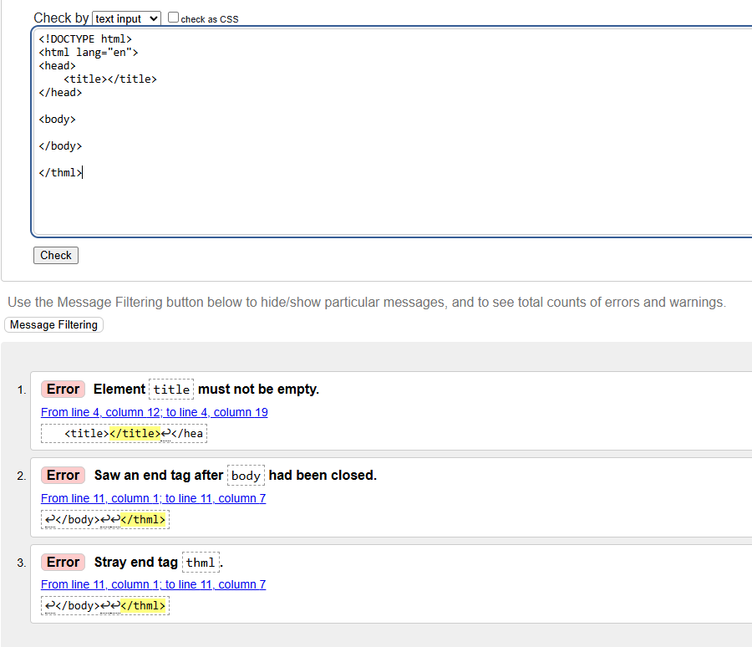
Fixed Starting code without error:
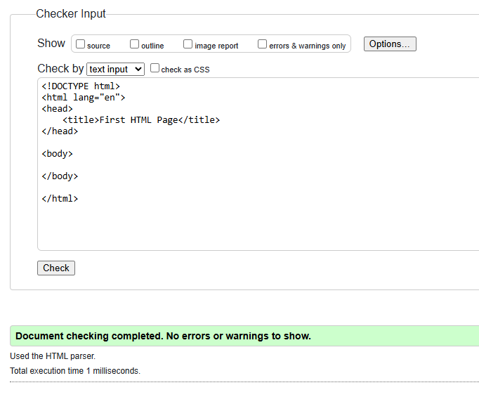
Updated Web Page check:
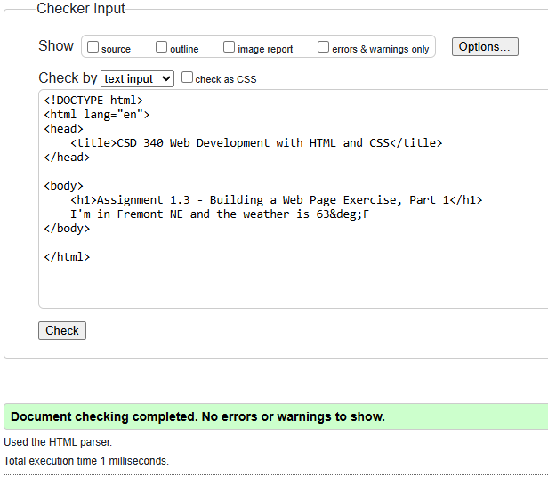
Screenshot of the browser:
